SUPREME COURT OF THE STATE OF NEBRASKA
CERTIFICATE OF AUTHORITY

This registration certificate is hereby issued by the Nebraska Supreme Court to Exact Firm Name.
______________________________________________________ _____________
(Exact Firm Name)
for the practice of law as a domestic professional organization in the form of a limited liability company.
The Clerk of the Supreme Court of the State of Nebraska does hereby certify that the member(s), manager, professional employees, and agents of the above-named limited liability company, to wit:
Name, Residence, Address, City, State, ZIP.
_______________________ ____________________________________
(NAME, RESIDENCE ADDRESS, CITY, STATE, ZIP)

Name, Residence, Address, City, State, ZIP.
_______________________ ____________________________________
(NAME, RESIDENCE ADDRESS, CITY, STATE, ZIP)

Name, Residence, Address, City, State, ZIP.
_______________________ ____________________________________
(NAME, RESIDENCE ADDRESS, CITY, STATE, ZIP)

PLEASE ATTACH SEPARATE LIST IF NEEDED

is/are duly licensed to practice law in the State of Nebraska, and the above-named limited liability company, complies with the provisions of the Nebraska Uniform Limited Liability Company Act and the canons, rules, and regulations imposed by the Nebraska Supreme Court for limited liability professional organizations.
The address of the limited liability company at which the applicant proposes to perform professional services is Address, City, State, ZIP.
_____________________________________________.
(Address, City, State, Zip)
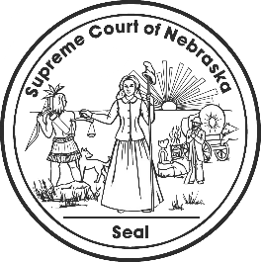
IN TESTIMONY WHEREOF, I have hereunto set my hand and caused to be affixed

the Seal of the Court, in the City of Lincoln, this __________________.

__________________________________________________
Clerk, Supreme Court of Nebraska

This certificate expires one year from the date of issuance.

