Deborah A. Minardi
State Probation Administrator

Corey R. Steel
State Court Administrator
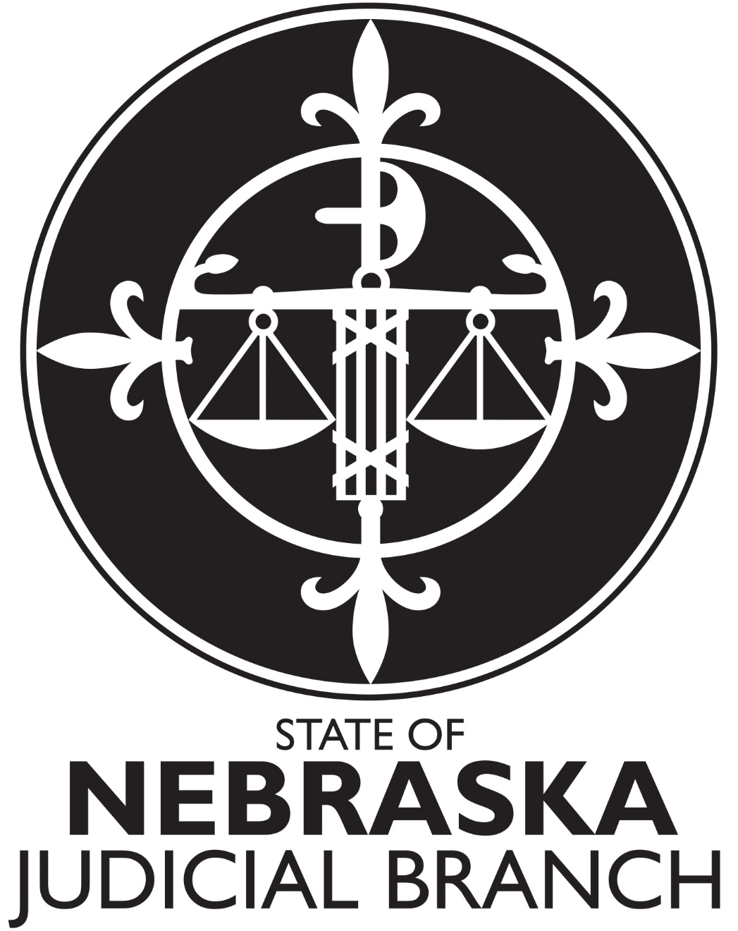

Evaluation Billing Worksheet

The Administrative Office of the Courts and Probation (AOCP) has a responsibility to refer justice involved individuals for targeted evaluations based on standard screening and assessment tools. The AOCP can provide financial assistance for evaluations based on eligibility requirements. The AOCP will use the Evaluation Billing Worksheet to identify the services conducted as part of the evaluation and to determine financial assistance and payment.

When you upload the evaluation to the voucher in the Registered Service Provider System, also upload the Evaluation Billing Worksheet. Please include any additional insurance/payment documentation such as Explanation of Benefits. Please refer all payment questions to the Quality Compliance Reviewers nsc.probationvouchers@nebraska.gov .

Please check the following service and CPT code, if applicable, for the service components completed as part of the evaluation process.

☐Initial Diagnostic Interview (IDI) 90791

☐Psychological Testing - First hour (60 minutes) 96130
☐Psychological Testing - Each additional hour (60 minutes) 96131

Total number of 96131

☐Test Administration and Scoring – First half-hour (30 minutes) 96136
☐Test Administration and Scoring - Each additional half-hour (30 minutes) 96137

Total number of 96137

Psychological Tests

☐Risk Assessment for Youth Who Sexually Harm H2000SK
☐Sex Offense Specific Evaluation (Adults)

The AOCP may request additional information in order to determine payment and completing this form does not guarantee payment. Request for payment for psychological testing over 5 units total is subject to an additional review by the AOCP. If you would like approval prior to completing psychological testing, you can email the Quality Compliance Reviewers nsc.probationvouchers@nebraska.gov requesting a prior review and approval. Please include the testing you plan to conduct as well as the rationale for the testing and the associated number of units.

By checking the service and CPT code and signing the Evaluation Billing Worksheet, you are attesting that you have completed the service(s) in its entirety and the service(s) meets the AOCPs Service Definitions, Standards of Practice and all related rules, regulations and guidance as set forth by the AOCP. The AOCP will consider a typed or electronic signature as valid attestation.

Juvenile - https://supremecourt.nebraska.gov/probation/community-based-programs-field-services-division/rehabilitative-services/juvenile-service-definitions

Adult - https://supremecourt.nebraska.gov/probation/community-based-programs-field-services-division/rehabilitative-services/adult-service-definitions

Click or tap to enter a date.

Psychologist or Provisionally Licensed Psychologist

Signature

